Name: Class:

Task 1
The table below shows four sensors. Identify the name of each sensor from the following:
Push button, oxygen sensor, cooking thermometer, ultrasonic sensor
Sensor | Sensor name
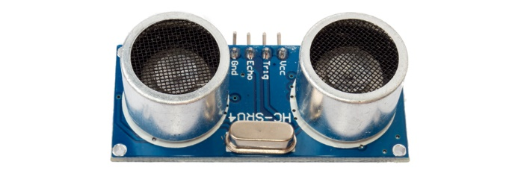
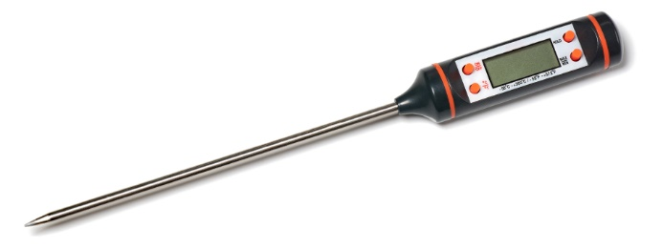

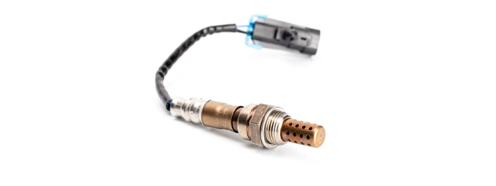

Task 2
Research three other sensors and for each one give an example of an automated system that may use it.
Sensor name | Image of the sensor | Example of where it may be used
 | 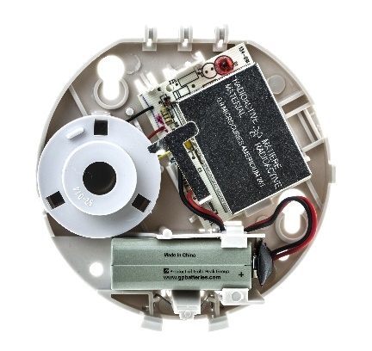
 | 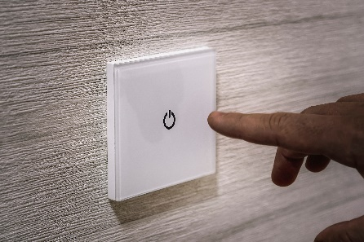
 | 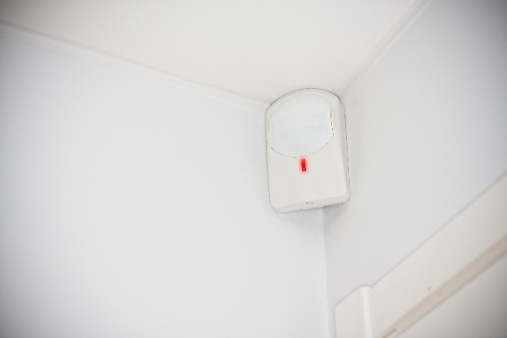

Task 3
Lighting is one area that can be controlled by automated systems.
(a) Explain three sensors and how they could be used to control a lighting system.
Sensor 1:

Sensor 2:

Sensor 3

(b) A farmer has automated lighting for a greenhouse that is used to grow lettuces. The lights need to turn on between the hours of 4pm and 11pm in the winter and 9pm and 11pm in the summer. The lights also need to turn if it is cloudy – this is detected by a light sensor reading of less than 5.
Develop an algorithm using pseudocode or English sentences for the automated lighting system.

Task 4
Work in a pair or small group. Choose one topic from the following topics:
Agriculture Weather Science
Your chosen topic: ___
Research your chosen topic to answer the following questions:
(a) Choose one specific area where automation is used in your topic area and write it below:

(b) Describe how automation is carried out. Remember to include any sensors that may be used in the automation.

(c) Give at least three advantages of the automation that you have chosen.

(d) Give at least two disadvantages of the automation that you have chosen.

